Activities: Blackboard Collaborate 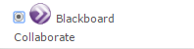
The Blackboard Collaborate activity allows you to create a Webinar or virtual classroom for your students. The main Blackboard Collaborate tool is an interactive whiteboard; instructors may use the whiteboard to write on, upload PowerPoints, conduct polls and quizzes and use breakout rooms. You can also have students follow you to your desktop to view Word, Excel or Internet pages. The instructor is able to show themselves on camera and chat with the students via a chat area. The sessions may be recorded for asynchronous viewing and review.
Besides using Blackboard Collaborate as an online classroom, you can also use this tool for instructor office hours, where students may drop in virtually to ask questions, to conduct homework reviews, and to demonstrate how to complete assignments or work through course content.

Contents
- Accessing Blackboard Collaborate
- Blackboard settings
- Opening a Blackboard Collaborate session
  - Join a Blackboard Collaborate session on Moodle
  - First time using Blackboard
  - Verify your system is setup properly
- Blackboard page tools
- Teaching with Blackboard Collaborate tips
- Notes

Accessing Blackboard Collaborate

- Go to your Moodle course page.
- Click on the Turn editing on button at the top right of the screen.
- Click Add an activity or resource.
- Click the radio button next to Blackboard Collaborate and click on the Add button.
The Adding a new Blackboard Collaborate page will appear.

Blackboard Settings
- Type a Title. The title of this session depends on whether you are opening a session for one class or the entire semester. Make a title that will clearly communicate the session agenda to the students. Example: Weekly Webinars (Mondays at 10:00 am) or Homework Help Online Class (Mondays 8:00 pm)
- Type a Session name. If you are creating one Blackboard session for multiple sessions, you will need to be very specific for the session name. It is possible to search for recordings using this session title, so you may want to include some reference to the course as well. Example: Math123_Chapter1 or Math123_HomeworkHelp_Chapter1
- Type a Description (optional). This will not be displayed when logging in to the Blackboard session.
- Set the time the Session begins and the Session ends.
- If you are making one Blackboard session for the entire semester, adjust the timing to extend across the entire semester.
- If you are making Blackboard sessions to place within the modules, set the timing for the specific session.
- Common module settings
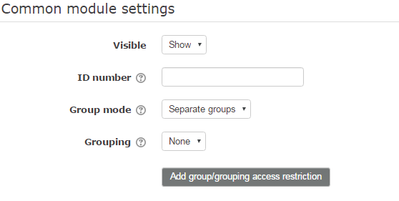
The Visible is used to hide or show the Blackboard session, but this may also be done on the home page of your course.
If you plan to mark the Blackboard session, the session will appear in the Grade Book under its ID number.
It is possible to set up Blackboard Collaborate sessions for groups (Group mode) in your class. These groups need to be set up first.
6. Restrict Access: You may assign certain restrictions for the student before they access Blackboard Collaborate.
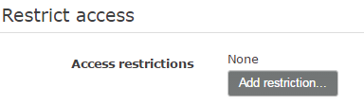

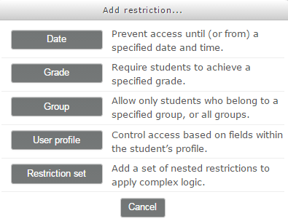

7. Schedule: Assigns the time you may log into the Blackboard session. The default is 30 minutes. This should not be changed for most instances. You should encourage students to login early.
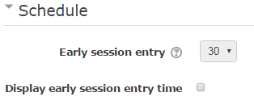

8. Session Attributes: In the Session Attributes section, Manual is the default Recording mode. This means you will have to click on ‘start audio’ to start your recording session.
The Max talkers is set to 6 as a default. This is the greatest number of speakers you may have in Blackboard Collaborate. When you are talking online, it is very difficult not to talk over other people with audio. (You may wish to turn students’ ability to use audio on and off when allowing students to participate as speakers.)
Restrict session Participants: This is an important feature. You may select a student or students to have access to the Blackboard Collaborate session. If a student wants to talk to you privately for extra help, this is a great means to meet them online. This feature will work if you do not have the group mode feature activated.
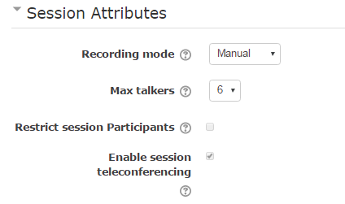

9. Session Grading: Use this section to set grading parameters. In most cases, Blackboard Collaborate will not be marked.
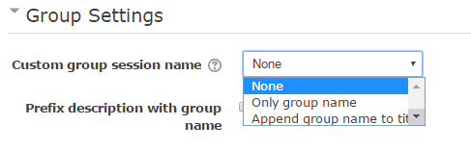
10. Group Settings: If the Blackboard session is for a specific group (see Settings #5), this section assists you with the naming of the Blackboard session.

11. Click on the Save and return to course or Save and display button.

Opening Blackboard Collaborate: Joining a Blackboard Session on Moodle
- Click on the Blackboard Collaborate activity.
2. Click on the Join Session link.
*If you do not see Join Session, please confirm that the session date is valid.
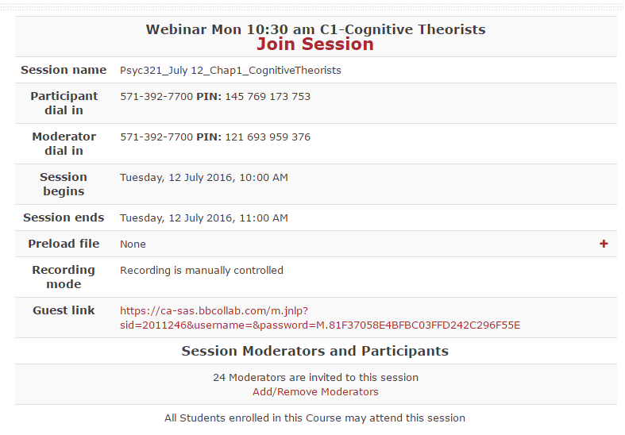
- The Blackboard Collaborate window will appear. Select Start session.
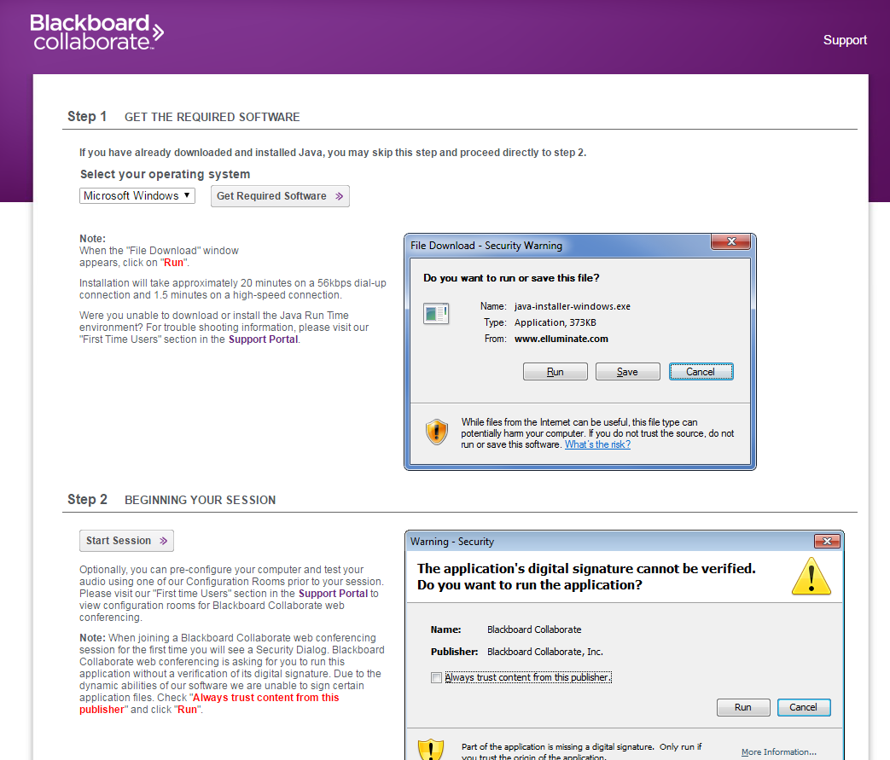

3. A series of pop-ups, including security prompts, will appear in the lower right of your screen. Some of these prompts are dependent upon your computer; not all of these may appear. If you are asked to upgrade Java software on NorQuest computers, select Later. You are unable to download newer software versions.
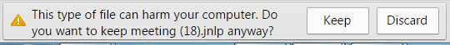

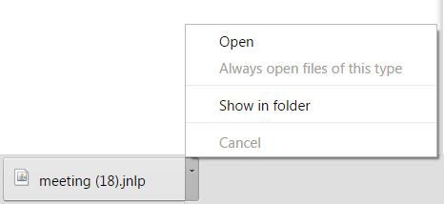

Java starts:
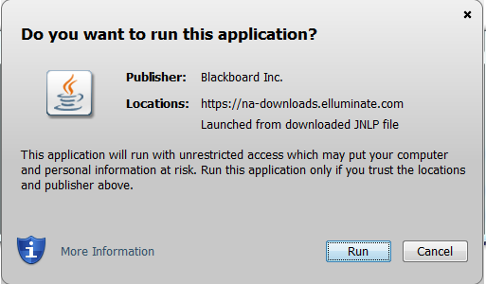

Wait for the Blackboard Collaborate screen to open.
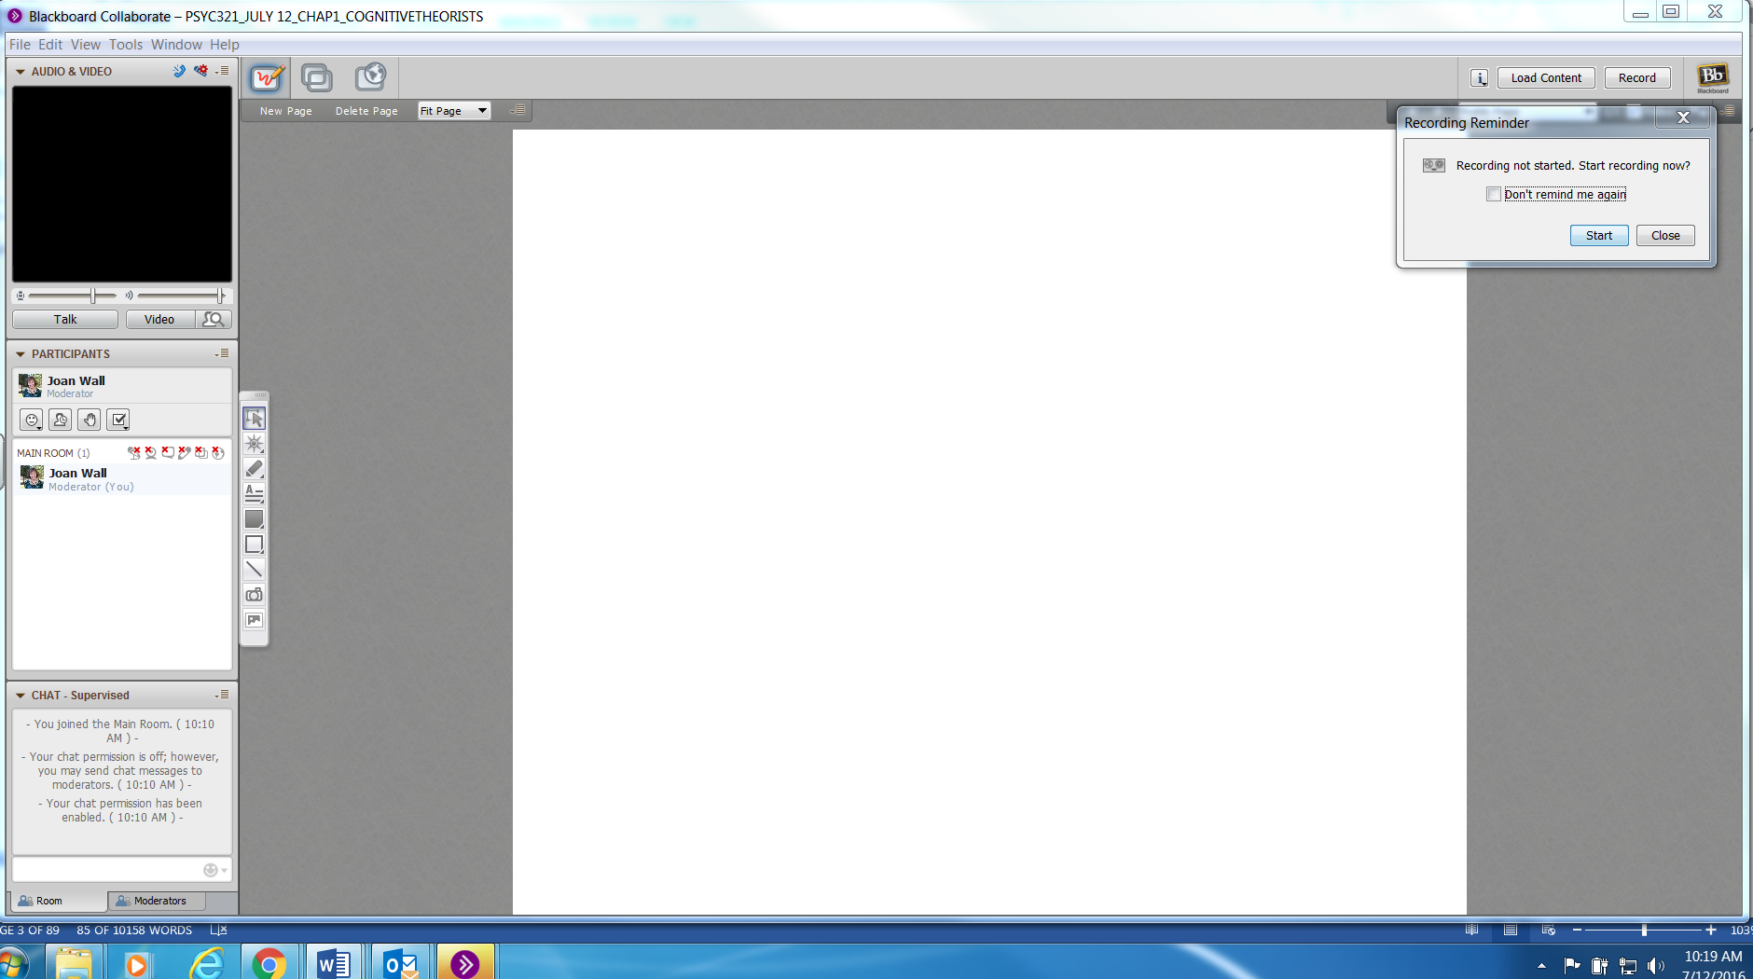
If you use Blackboard Collaborate for the first time or you change computers, you have to use the Audio Setup Wizard (Tools > Audio > Audio Setup Wizard). Otherwise you will not hear anything and the students will miss your beautiful voice. Click here for more details.

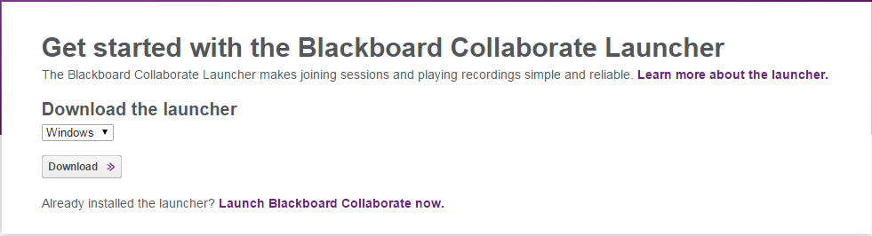
1. The first piece of software is the launcher. Click on the ‘Download’ button if you have never used BBC on your computer before, or if you are using a computer that uses DeepFreeze (eg. classroom computers). If you have downloaded the launcher before, you can click on the ‘Launch Blackboard Collaborate now’ link:

2. If you are using Internet Explorer, a bar will pop up on the bottom of the page asking if you want to open or save dropin.collab. Click ‘Open’. If you are using Google Chrome, the file will appear at the bottom of the page. Click on it to open it. NOTE: If you don’t have the launcher installed, dropin.collab will not open and you will not be able to start BBC.

Blackboard Collaborate needs two pieces of software when used on a Mac. These are downloaded when you click on a link provided to you to attend an online session.
- The first piece of software is the launcher. Click on the ‘Download’ button if you have never used BBC on your computer before. If you have used BBC before on your Mac, you can click on the ‘Launch Blackboard Collaborate now’ link:

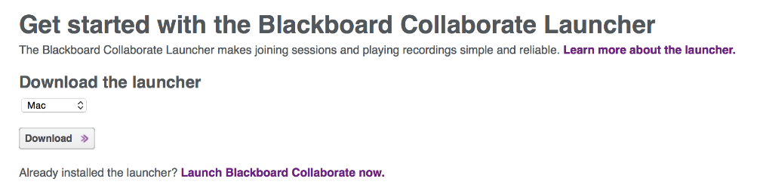

- Go into your ‘Downloads’ folder. The zip file containing the launcher should be there. Unzip the file, and move or save it to your Applications folder. If your Mac has unzipped it already, you will see the launcher itself. By clicking on this file, you can move the launcher to the Applications folder.

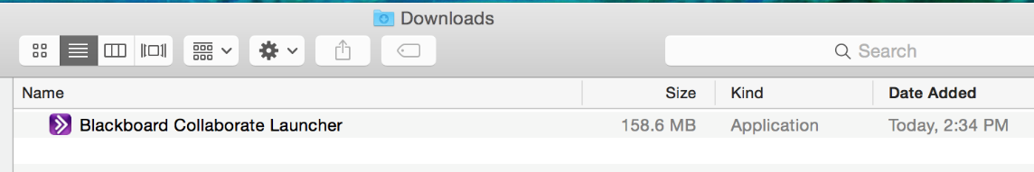
- Once the launcher has been downloaded and unzipped, you may click ‘Join’ to launch the session.
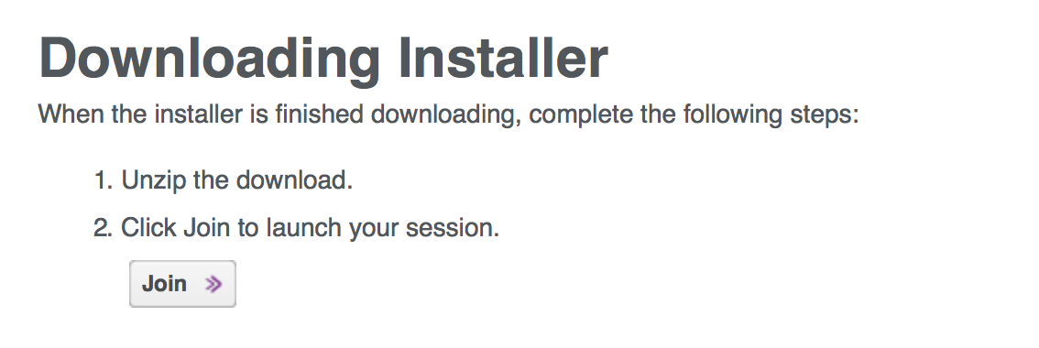

- You will now see the ‘Log In to Session’ screen, where you can enter your name as you want to see it in the session.
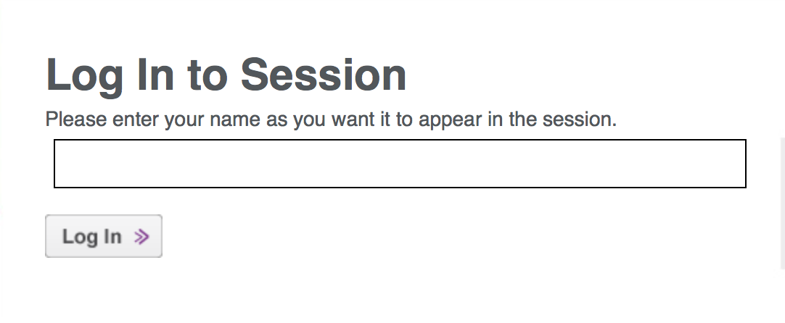

- Once you have clicked the ‘Log In’ button, the session file (named ‘dropin.collab’) will start downloading. Once it has finished downloading, go to your Downloads folder to open it. You will then see the following dialog box. Click ‘Run’.
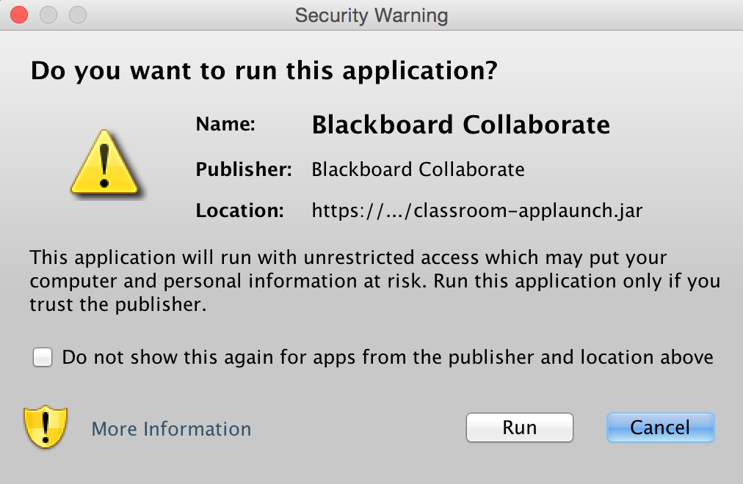

- In the dropdown menu on the following dialog box, select ‘LAN’ and click ‘OK’.
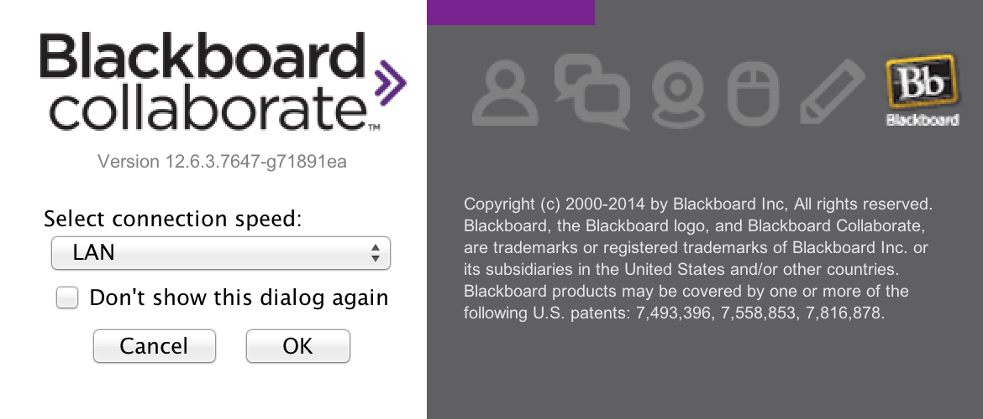

- Once the launcher has been downloaded and unzipped, you may click ‘Join’ to launch the session.


- You will now see the ‘Log In to Session’ screen, where you can enter your name as you want to see it in the session.


Setting up Blackboard: Audio
1. Every time you start BBC, make sure to configure your audio and microphone settings. To do this, find the ‘Audio Setup Wizard’ in the ‘Tools’ menu.
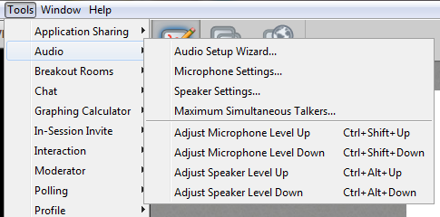
2. From the prompt box that pops up, select the audio output device you might be using (eg. speakers attached to your computer or headphones). Click ‘ok’. If you do not see your speakers listed, make sure they are plugged in and click ‘Refresh’.
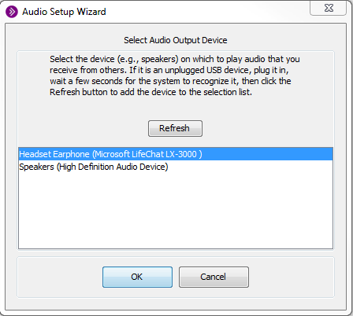
3. Press ‘Play’ on the next prompt box. You will now hear a prerecorded audio message through the device you selected. Try changing the volume. When you are done, click ‘Stop’. The next box will ask if you were able to set the speaker volume to a comfortable level.

4. You will now be prompted to select an audio input device (ie. the microphone you wish to use). Select the one you would like to use from the prompt box and click ‘ok’. If you do not see it there, make sure the microphone is plugged in and click ‘Refresh’.

5. You will now be prompted to record an audio sample to test your microphone. When you are ready, click ‘Record’.
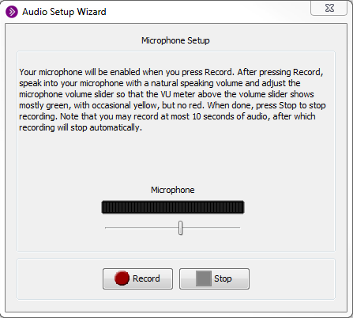
6. The next prompt box will require you to play back what you have just recorded. Click ‘Play’ to hear your audio sample, and ‘Stop’ when you are done. The next box will then ask whether the microphone volume is at an acceptable level. You are done!

Setting up Blackboard: Communication Tools
1. Every time you start BBC, make sure to configure your audio and microphone settings. To do this, find the ‘Audio Setup Wizard’ in the ‘Tools’ menu.

2. From the prompt box that pops up, select the audio output device you might be using (eg. speakers attached to your computer or headphones). Click ‘ok’. If you do not see your speakers listed, make sure they are plugged in and click ‘Refresh’.

3. Press ‘Play’ on the next prompt box. You will now hear a prerecorded audio message through the device you selected. Try changing the volume. When you are done, click ‘Stop’. The next box will ask if you were able to set the speaker volume to a comfortable level.

4. You will now be prompted to select an audio input device (ie. the microphone you wish to use). Select the one you would like to use from the prompt box and click ‘ok’. If you do not see it there, make sure the microphone is plugged in and click ‘Refresh’.

5. You will now be prompted to record an audio sample to test your microphone. When you are ready, click ‘Record’.

6. The next prompt box will require you to play back what you have just recorded. Click ‘Play’ to hear your audio sample and ‘Stop’ when you are done. The next box will then ask whether the microphone volume is at an acceptable level. You are done!

Navigation Tools
New Page: Add a new page to your presentation.
Delete Page: Delete a page from your presentation.
Fit Page dropdown bar: Adjust the size of your presentation.
Additional options (beside dropdown bar): Add, delete, and clear.
Back: Go back one page in your presentation.
Forward: Go forward one page in your presentation.
Room Navigation dropdown bar: Navigate between rooms in your presentation.
Page Counter: Tells you what page you are on, out of the total number of pages in your presentation.
Follow: Cause all participants to move to the same screen as you, the moderator.
Explore Mode: Allows you to explore other pages while leaving participants on the current page.
Show Page Explorer: Shows a popup box with thumbnails of all the pages in the presentation.


Whiteboard: Write and draw on this surface. You can also load PowerPoints into this surface.
Application Sharing: Share applications with participants, including Internet Explorer, Google Chrome, Microsoft Office products, etc. so they can see what you are doing. You can also share your entire desktop.
Web Tour: Enter an URL and share a webpage with your students inside of Blackboard Collaborate instead of sharing another browser. This browser is an older version of Internet Explorer - be aware that some functionality of the website may be reduced.

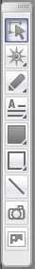
Whiteboard Tools:

Select: Select objects on the whiteboard.
Pointer: Use this to point to objects on the whiteboard.
Pen/Highlighter: Use this to write or highlight text.
Text: Add text to the whiteboard.
Filled Shapes: Add a coloured rectangle or circle.
Outlined Shapes: Add outlined (unfilled) rectangles or circles.
Line: Add straight lines.
Screen Capture: Add a screen capture to the whiteboard.
Clip Art: Add clip art to the whiteboard.

Other Interesting Tools

File Menu:
Save: Save presentations as PDF files, including any annotations.

Tools Menu:
Breakout Rooms: Create rooms for groups of students to work together privately.
Polling: Change the polling button in the Chat Tools to use multiple choice options, etc.
Timer: Makes a sound after a set amount of time (eg. for quizzes).

Window Menu:
Show File Transfer Library: Transfer files (eg. a PDF handout) to participants.
Show Graphing Calculator: Use Blackboard Collaborate’s graphing calculator.

Notes:
For additional information check Moodle Docs Page Resource or contact Moodle Help.

